**Programming Notes:**

For Lifecycle Update:

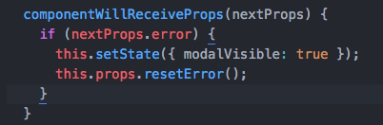

* Use componentWillReceiveProps().
* Having nextProps as an argument allows you to take the next props and put it back into the function. If we used props only, the component will update one step backwards.
* For example, I want the app to update the modal whenever there is an error. If I use this.props.error, I will get an update only after I make 1 more changes. If I use nextProps.error, I will get the modal update right away rather than having to carry out 1 more steps.
* componentWillReceiveProps(nextProps) { /*use nextProps in here*/} allows you to carry out live updates.

Firebase Unique username:

To check if data exists in the firebase database, use this =>

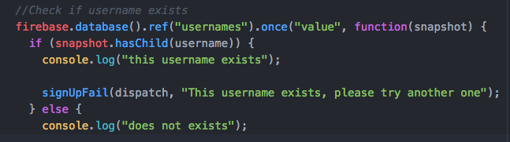

If we were to put username = username.replace … it will manipulate the function when redux goes through it the first time. Therefore, don’t put manipulation in redux. Instead, add variables in.

